nCounter system: an easy Digital Quantiﬁcation of Nucleic Acids and Proteins

SEMINAR | SFR Biosciences Lyon 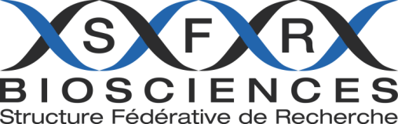
Jeudi 23 juin 2016
A 14h00

Lieu : Amphithéâtre Tour INSERM CERVI

Digital Quantiﬁcation of Nucleic Acids and proteins utilizing a Colour-coded Barcode Technology
Valérie Lacoste, Ph.D. | Regional Area Manager | NanoString Technologies Europe

Contact Information: Valérie Lacoste : vlacoste@nanostring.com

Visit our web site at www.nanostring.com for more information.

